IST 440W

Wonseok Song

**Testing**

Figure 1 Figure 2

As users are trying to put anything beside the specific medicine name that are in database, it causes the error with no list showing up. I resolve this error by providing pop up window if any other words beside the medicine names that are in database are entered. Repeated actions for searching for non-related words might cause crashes so enabling searches for only specific medicine names is required to prevent from crashes.

Figure 3 Figure 4

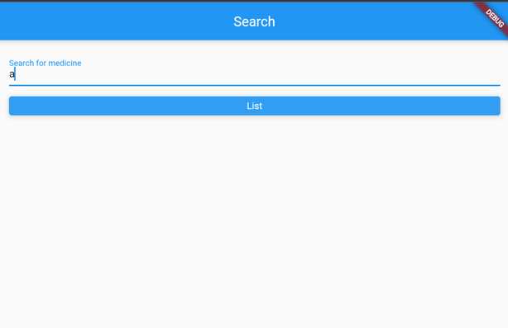

As you can see, I implemented the pop up window to notify user if they have not put valid value into the search engine.

By adding these lines into my code, allows me to solve the error of when user type non-sense value for search engine. It only looks for certain words of names for medicines.

**Front End Unit Testing**

Using flutter test feature installed in flutter is checking up for the elements and widgets and interaction. This will fail if one or more missing elements or widget. It is good basic tool for testing on application I have built.